BLESSED VICTORS SECONDARY SCHOOL BUWALULA

Mid term III

Physics

Paper 1

2 hours

**STUDENT NAME: __________________________________________________**

**INSTRUCTIONS TO STUDENTS**

This paper consists of two sections; Section A and Section B.

Attempt all questions in section A and section B

**Section A (40 mks)**

1. A heap of weed of mass 3 tonnes is moving towards the turbines at the Jinja power station. A group of engineers needs to use a machine operating at 20 kW for five minutes, to remove the weed from the river as shown in Figure and place it at the bank, which is 15 m above the river.

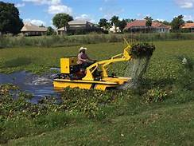

Figure 1

Determine the efficiency of the machine. (3 marks)

……………………………………………………………………………………………………………………………………………………………………………………………………………………………………

Comment on the efficiency of the machine. (1 mark)

………………………………………………………………………………………………………………………..

2. On a hot day, a student dropped three ice cubes at -6 oC in a jug of water at room temperature. If the final temperature of the mixture after all the ice has melted was 16 oC,

.i) Sketch a temperature-time graph for the ice. (1 mark)

.ii) Describe the key features of your graph in (i) above. (3marks)

……………………………………………………………………………………………………………………………………………………………………………………………………………………………………………………………………………………………………………………………………………………………..

3. A car of mass 1200 kg travelling at 15 m s–1 comes to rest over a distance of 30 m. Find;

The average retardation (2 marks)

……………………………………………………………………………………………………………………………………………………………………………………………………………………………………………………………………………………………………………………………………

4. During a thunderstorm, a certain farmer’s cow that was sheltering under a tall tree was struck by lightning and it fell dead as shown in Figure 2.

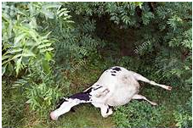

Figure 2

His village mates attributed this incidence to witchcraft. As a Physics student, explain to the villagers how lightning is caused and that the incident was not induced by witchcraft. (4 marks)

……………………………………………………………………………………………………………………………………………………………………………………………………………………………………………………………………………………………………………………………………………………………………………………………………………………………………………………………….

5. Ainomugisha charged a sharp pointed conductor upto 20 coulombs. She then measured the charge using a goldleaf electroscope after 30 minutes and she got 12 coulombs.

.i) What caused the reduction in charge (1 mark)

………………………………………………………………………………………………………………………………………………………………………………………………………………………………………………

.ii) Explain the process that caused the reduction in charge (3 marks)

……………………………………………………………………………………………………………………………………………………………………………………………………………………………………………………………………………………………………………………………………………………………………………………………………………………………………………………………….

6. A head teacher instructed the school carpenter to make a notice board of dimensions 1.5 m by 0.5 m. If each notice is written on a piece of paper of dimensions 21 cm by 30 cm, what is the maximum number of notices that can be put on the notice board at any one time? (4 marks)

…………………………………………………………………………………………………………………………………………………………………………………………………………………………………………………………………………………………………………………………………………………………………………………………………………………………………………………………………………………………………………………………………………………………………………………………………….

7. A plumber noticed that the bath in Etomet’s home was not functioning satisfactorily because the water pressure at the showerhead shown in Figure 4 was too low.

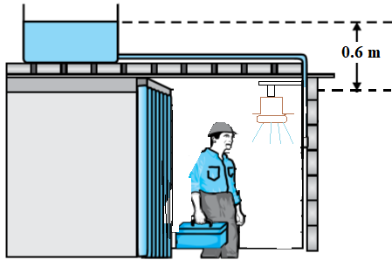

Figure 4

Taking density of water = 1000 kg m–3, g= 10 N kg–1,

.i) What is the water pressure at the showerhead? (2 mks)

………………………………………………………………………………………………………………………………………………………………………………………………………………………………….

.ii) What must the plumber do to increase the water pressure at the showerhead to 15,000 Pa? (2mks)

………………………………………………………………………………………………………………………………………………………………………………………………………………………………………………………………………………………………………………………………………………………

.iii) Jovia's cup has a diameter of 14cm. When filled with porridge it weighs 10N. Find the pressure Jovia's cup exerts on the table when it is full of porridge. (3marks)

………………………………………………………………………………………………………………………………………………………………………………………………………………………………………………………………………………………………………………………………………………………

8. On a certain sunny day, a taxi driver saw a pool of water ahead on a tarmac road as he was driving as shown in Figure 5.

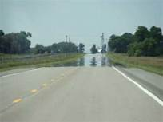

Figure 5

To his surprise, the pool disappears as he approaches it. With the aid of an appropriate ray diagram, explain the taxi driver’s surprise. (4mks)

**Section B**

9. (a) Muganga was puzzled that the shallow end of the swimming pool at his school appeared to be about 1.5 m deep when in the actual sense it was 2.0 m.

.i) Use a ray diagram to illustrate Kalindi’s puzzle. (4 marks)

.ii) Use your ray diagram above to explain to Kalindi why the swimming pool appeared shallower than it actually is. (4 marks)

.iii) Determine the refractive index of the water in the swimming pool at Muganga's school (2marks)

(b) A barber was given a curved mirror of focal length 30 cm so that he could use it as a shaving mirror in his salon.

.i) Identify the type of curved mirror given to the barber. (1 mark)

.ii) Use a ray diagram to illustrate the use of the selected curved mirror as a shaving mirror. (4 marks)

.iii) What are the properties of the image formed above? (2 marks)

.iv) Which type of curved mirror is suitable to be used as a side mirror and why (2marks)

10. (a)One of the most important components of our solar system is the sun. Another important component of our solar systems are the big masses called planets.

i). Name all the planets found in our solar system. (4 marks)

ii). Identify the planet that sustains life in our solar system. (1 mark)

iii). How are the times and seasons of the year explained on the planet mentioned in (ii) above? (5 marks)

(b) Explain the statement that “the sun has a life cycle”. (5 marks)

11. Figure 7 shows the arrangement of apparatus by a learner to investigate the relationship between the mass of lead shots, m, and the immersion depth, h, of the cylinder. The learner placed different masses of lead shots in the cylinder and measured the corresponding immersion depths. A graph of immersion depth, h, against mass of lead shots, m, was then drawn as shown in Figure 8.

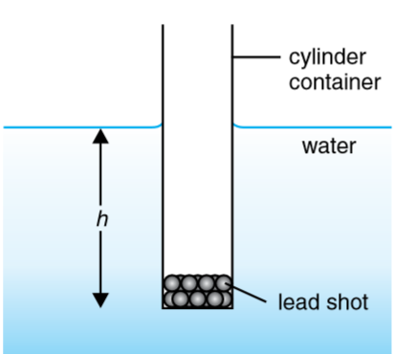 Figure 7 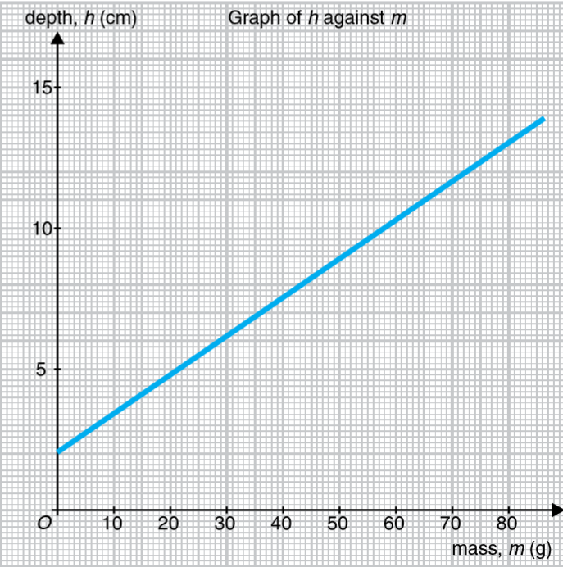 Figure 8

(a) Based on the graph in Figure 8,

(i) state the relationship between m and h. (2 marks)

(ii) what is the value of h, if the cylindrical container is empty? (2 marks)

(iii) calculate the gradient of the graph. (4marks)

(b) (i) Using the value of the gradient of the graph obtained in (a)(iii) and the relationship, , where A is the cross-sectional area of the cylindrical container, in cm2, calculate the value of A. (2 marks)

(ii) Find the volume of the water displaced when 50 g of the lead slots are added into the cylinder.(3 marks)

(c) Identify one principle in Physics connected with this experiment. (1 mark)

12. Members of your community have continuously complained about eye sight problems. The complaints are not only coming from elderly but also children. The eye care department of your Health centre III is planning to organize a medical camp in your village. You have been selected to report to the medical team the eye sight problems of people in your area and the appropriate measures to be undertaken. Write a brief report that you will present to the head of the medical team. (10 marks)